Press Release
For immediate release

The Bellevue Resort leads International Coastal Cleanup #SeaTheChange in Bohol

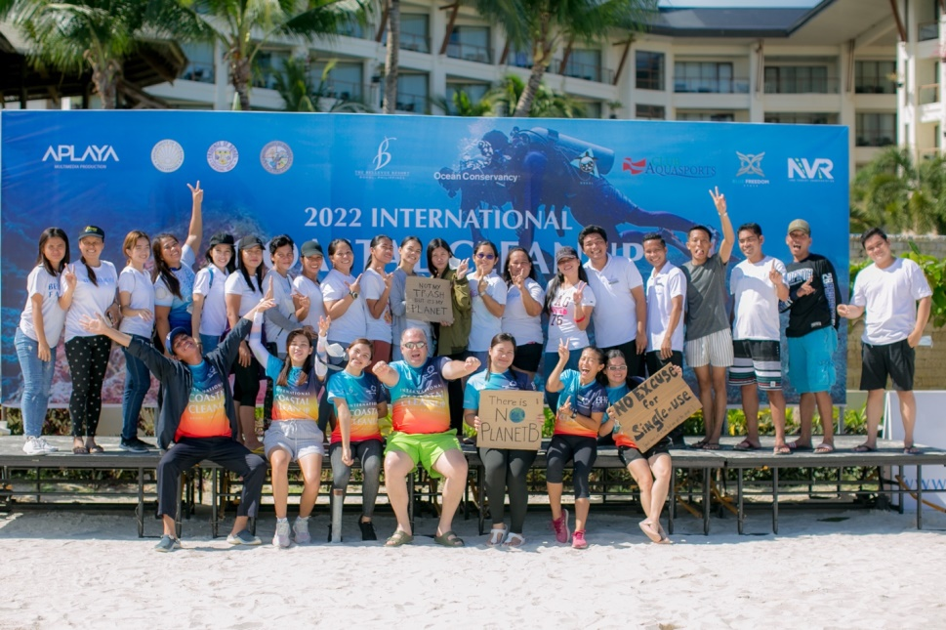

Bohol, Philippines, September 2022 - More than half a thousand volunteers from local organizations and private sectors, including frontliners, professionals, employees, students, divers, and many more gathered together to collect and segregate an estimated 1,713 kg of non-biodegradable waste at the recently concluded 37th International Coastal Cleanup (ICC) day hosted by The Bellevue Resort in Doljo Beach, Panglao, Bohol.

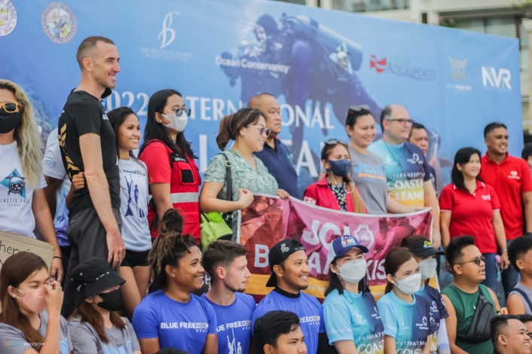

The Bellevue Resort led the ICC day last September 17 as part of a global collaboration for Ocean Conservancy’s worldwide campaign. This is its fifth year in a row to stand in support of their advocacy for environmental preservation. Teamed up with the resort were the Department of Tourism, Provincial Government of Bohol, Municipality of Panglao, Plastic Free Bohol, Blue Freedom Apnea, Club Aquasports, and NVR Land Tourist Transport.

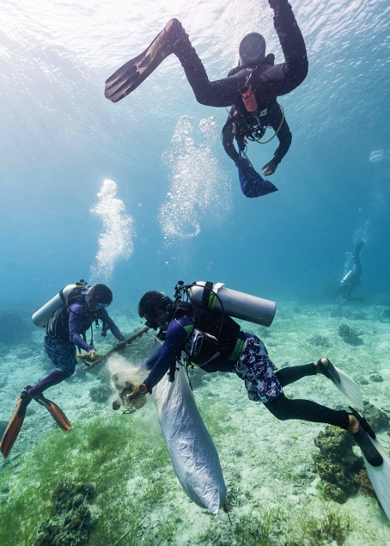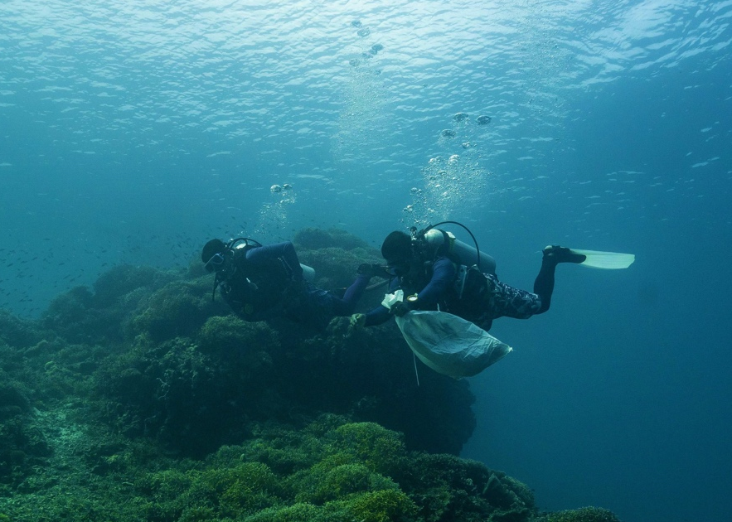

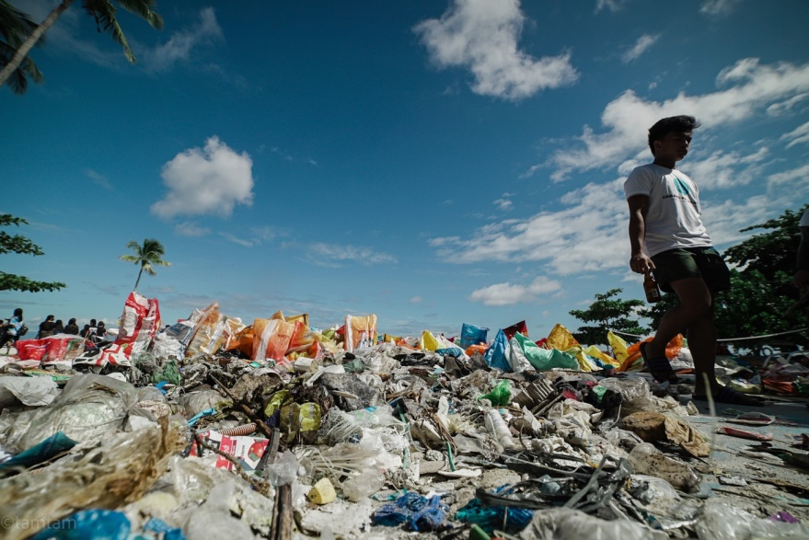

The Bellevue Resort – Bohol is a two-time ASEAN Green Hotel awardee, proudly a leader for sustainability. This eco-friendly five-star hotel has consistently spearheaded meaningful initiatives for responsible tourism in Bohol since its opening in 2012. Today the resort continues to head and take part in various efforts to promote environmental protection and conservation in the Philippines.

To know more about the resort, visit www.thebellevuebohol.com.

###

